Geocoding with LION

Updated: May 3rd, 2010

With the current release of LION, it will no longer be necessary in most cases to create an address locator. The LION geodatabase now includes two prebuilt address locators: one for geocoding based on street address and BoroCode, and another for geocoding based on the street address and zipcode. The locators require the use of ArcGIS 9.3 (or above), but are ready to use without any other requirements. This document is provided only for the special cases where the user will need to create a custom address locator.

Please make sure that the following system requirements have been met before proceeding.

System Requirements
- ArcGIS 9.3 (or above) with at least one ArcView, ArcEditor, or ArcInfo license
- 100 MB of disk space

Instructions – Download and prepare the data
  - Download and unzip the LION geodatabase from City Planning, if you haven’t already.
  - With Windows Explorer, browse to the lion.gdb file geodatabase you downloaded.
  - Right click the geodatabase and choose properties.
  - Uncheck the Read Only property, if necessary. Click OK. Choose to apply changes to this folder, subfolders and files. Click OK.
Instructions – Add the locator system files (*.lot & *.mat) files to your computer
Along with the data you downloaded there are two files required for creating the geocoding locator:
- NYC LION Geocoding.lot – Copy this file to C:\Program Files\ArcGIS\Locators
- lion1.mat – Copy this file to C:\Program Files\ArcGIS\Geocode

Important: Unless you or your system administrator made changes, one of the above directories is where ArcGIS is installed. If you do not find the above folder on your computer, ask your system administrator or GIS manager where ArcGIS is installed on your machine. Do not continue unless you can add the
NYC Lion Geocoding.lot file in your Locators folder.

Instructions – Create the Address Locator
At ArcGIS 9.3 (or above), address locators can now be stored as stand alone files or with a geodatabase. The following instructions describe how to add the locator to the LION geodatabase.
- Open ArcCatalog.
- Navigate to inside the LION file geodatabase.
- Right-click and choose New → Address Locator.
- In the Create New Address Locator dialog, scroll down and choose NYC Lion Geocoding. Click OK.
- A large dialog will open up. In the upper left of the dialog, type in a name for the new locator.
- Under the Primary table tab, for Reference Data: click the browse button (looks like a folder).
- Browse to the LION Geodatabase and choose the LION feature class. Click the Add button.
- Check the House From Left, House To Left, House From Right, and House To Right entries. They should be filled in with the LLo_Hyphen, LHi__Hyphen, RLo_Hyphen and RHi_Hyphen fields, respectively.
Important – If you have replaced the hyphens in your Queens addresses with zeros (e.g. 12-34 changed to 12034), you must choose the FromLeft, ToLeft, FromRight, and ToRight fields, instead of the fields listed above in step 8. Otherwise, you won’t be able to successfully geocode addresses in Queens.

- Click the drop down next to Left Zone: and choose LBoro*.
- Click the drop down next to Right Zone: and choose RBoro*.
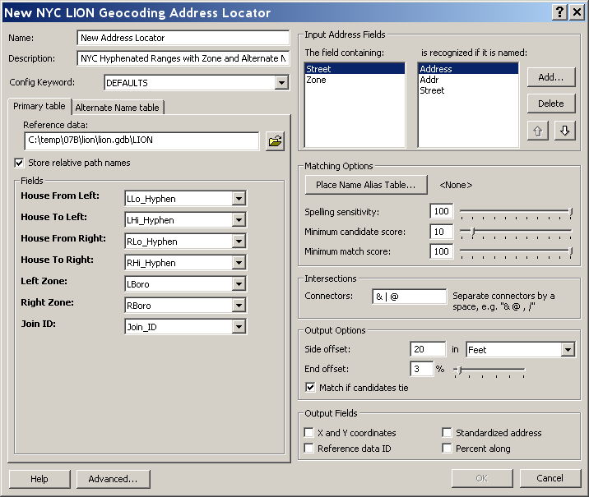
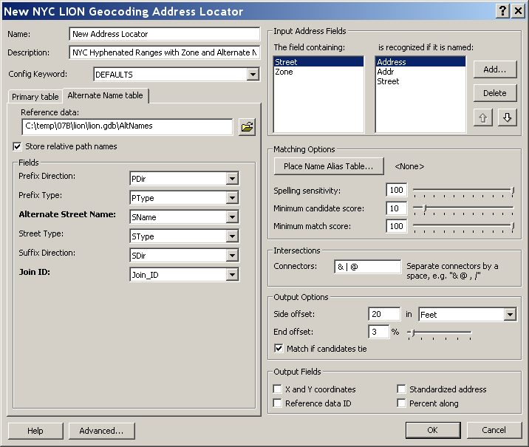
- Make sure the drop down next to Join ID: reads Join_ID.

- Click the Alternate Name table tab.
- Under Reference data: click the browse button.
- Browse to the Lion database and choose the AltNames table. Click the Add button.
- Check the address fields. They should read: PDir, PType, SName, SType and SDir, respectively.
- For Join ID: make sure the Join_ID field is chosen.
- Set any other matching options you want. All data was tested with the default settings (match score, offset, output fields, etc…).
- Click the OK button in the lower right corner of the dialog to create the new address locator. This will write some index tables to your LION GeoDatabase which will be used to improve geocoding speed.

ArcGIS should now be ready to geocode addresses using LION streets. If you are unfamiliar with geocoding addresses, refer to “Geocoding addresses”, chapter 15 of the book “Using ArcMap”, which comes with your ArcGIS software.

*Using LBoro and RBoro will provide the most accurate results, however users do have the option of choosing LZip and RZip for their left and right zones if their data includes zipcodes but not Borough Codes (See LION metadata for definition of Borough Codes).

